Circulation Stations
This worksheet corresponds with stations around the classrooms. Work in groups of 3 and do the stations in any order.
Name: ___________________
My mark: _________/20
Teacher mark: ________/20
Station 1: Blood smear under a microscope
Materials:
- Microscope
- Blood Smear Slide
Look at the slide labelled “Human blood smear” under the microscope at high magnification (400 X).
Step 1: Focus on any cells that you can find under low magnification
Step 2: Increase the magnification and focus the microscope again (you shouldn’t have to change the magnification significantly).
Step 3: Increase the magnification again and focus on the blood cells on high magnification.
Step 4: Draw a biological drawing of what you see. (2 marks)
Include the following:
  A sketch of any cells that you see (remember: no shading)
  The following labels (if applicable): red blood cell, white blood cell, platelet.
  Include the magnification

___________________________________
Question 1-A: (1 mark)
What is the most plentiful cell in human blood? __________________________________________
Question 1-B: (1 mark)
What is the cell responsible for clotting human blood? _____________________________________

Station 2: Cardiac muscle cells and skeletal muscle cells
Materials:
- Microscope
- Picture “A”
- Picture “B”
Examine the differences between cardiac muscle cells (those found in your heart) and skeletal muscle cells.
Cardiac Muscle Cells | Skeletal Muscle Cells
Cardiac muscle tissue occurs only in the heart. Its cells are joined end to end. The resulting fibers are branched and interconnected in complex networks. Each cell has a single nucleus. At its end, where it touches another cell, there is a specialized intercellular junction called a gap junction, which occurs only in cardiac tissue. Cardiac muscle is controlled involuntarily. This tissue makes up the bulk of the heart and is responsible for pumping blood through the heart chambers into the blood vessels. | Skeletal muscles are composed of groups of muscle fibers in an orderly arrangement. A small muscle may be only a few bundles of fibers, while the major muscles in the body, such as the gluteus maximus that forms the bulk of the buttock, are made up of hundreds of bundles. Movement of the skeletal muscle is under the control of the brain. Unlike cardiac muscles, skeletal muscles do not have gap junctions.
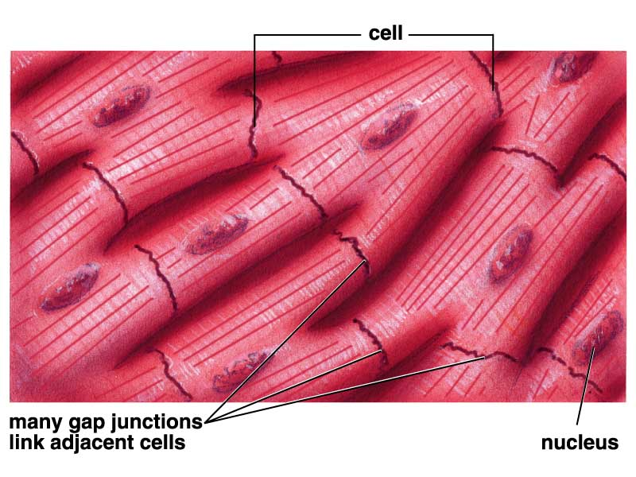

Question 2-A:
Observe picture A under high magnification. Identify it as either cardiac muscle cell or skeletal muscle cell.
________________________________
Question 2-B:
Observe picture B under high magnification. Identify it as either cardiac muscle cell or skeletal muscle cell.
________________________________

Station 3: The effects of breathing in water
Materials
- 2 – 80 mL beakers
- Tap water
- Universal indicator
- Straw
* Wear safety goggles for this station
Blood is responsible for delivering CO₂ from body cells to your heart and ultimately to your lungs. You are then able to exhale this CO₂. Carbon dioxide changes to carbonic acid (H₂CO₃) in water, which lowers the pH of water.
Step 1: Put on safety goggles. Rinse and fill the two of the provided beakers with 40 mL of tap water.
Step 2: Using a clean straw, blow in the water of Beaker A for 2 minutes.
Step 3: Add 5 drops of universal indicator to each beaker. Observe the colour.
Question 3-A:
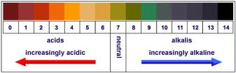
Using the pH chart above in the following chart: (3 marks)
Beaker | Carbon dioxide (carbonic acid) concentration  (high/low) | Colour after adding universal indicator | pH
A
B

Question 3-B:
With the knowledge that CO₂ also dissolves as carbonic acid in your blood, how will the pH of your blood be affected with the build up of CO₂? (1 mark)
_________________________________________________________________________________________________________________________________________________________________________________________________________________________________________________________________________________
Station 4: Blood Pressure
Using the electronic sphygmomanometer, take the blood pressure of a group member. Be sure to do the following:
- Deflate the cuff before starting
- You should be able to fit 2 fingers between the cuff and the arm
- Inflate the cuff until the up arrow disappears
- Relax, be still, and don’t talk (or laugh) until the sphygmomanometer is finished
Question 4-A:
Record the blood pressure: (1 mark)
______/________
Question 4-B:
Which of the numbers is your systolic pressure? ____________ (1 mark)
Which of the numbers is your diastolic pressure? ____________ (1 mark)
Question 4-C:
According to your notes, is your blood pressure in the normal range? ___________________________ (1 mark)
Station 5: Blood vessels
Using the pictures provided, identify each (A, B, C, or D) as being an artery, capillary, or vein. You may use each word once, more than once, or not at all.
Question 5-A:
Fill in the following chart: (4 marks)
Picture | Blood Vessel | Direction of blood flow
A
B
C
D

Station 6: How much blood does the heart pump?
Materials: a bucket with 4 litres of water, an empty bucket, a 5-ounce cup and a timer
Task: one person needs to transfer the water from one bucket to the other. Another team member will time it, to see how fast you can transfer the water from one bucket to the next.
Learning: How long did it take to transfer the water? The amount of water the cup holds represents the amount of blood your heart pumps each time it beats. It takes your heart about one minute to pump 4 litres of blood.
Questions:
- How long did it take to transfer the water? (1 mark)
________________________________________________________________________________________
- How much blood does your heart pump in a day? (1 mark)

________________________________________________________________________________________
________________________________________________________________________________________
Station 7: Your heart is a muscle!
Materials: one tennis ball per student and a timer
Task:
- Hold a tennis ball in your hand and squeeze the ball tightly. The force needed to squeeze the ball is similar to the force needed to squeeze blood out of the heart.
- Squeeze the ball as hard as you can about 70 times in one minute
Questions:
- How does your hand feel after one minute? (1 mark)
________________________________________________________________________________________
________________________________________________________________________________________
- What does this demonstrate about the heart muscle? (1 mark)
________________________________________________________________________________________
________________________________________________________________________________________

